Bioinformatics project: Transcriptomic Profiling of Extracellular Vesicles Released by Human Bronchial Epithelial Cells
Project supervisor: Professor Lucy Fairclough, Dr Georgina Hopkins, Dr Hannah Jackson
Background:
- Extracellular vesicles (EVs) are membrane-bound particles released by cells that mediate intercellular communication by transferring RNA, proteins, and lipids to recipient cells (Fig. 1).
- Airway epithelial cells are a major source of EVs in the lung and play a central role in regulating immune and inflammatory responses, particularly in respiratory diseases, such as allergic asthma.
- The goal of this project is to characterise and analyse the miRNA content of EVs released by human bronchial epithelial cells, and to compare miRNA cargo of EVs from cells exposed to different allergen exposures. This will provide insight into pathways potentially involved in airway immune signalling and allergic sensitisation.

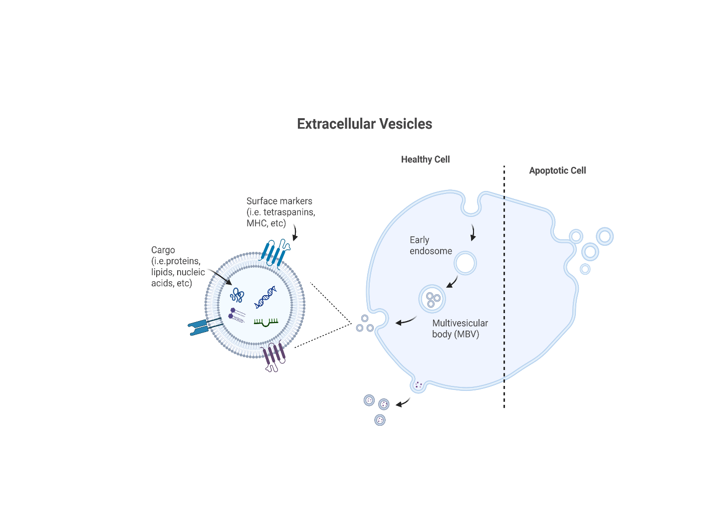
Figure 1. Extracellular vesicle formation.

Lab method:
Project 1 (Protease allergens)
- Primary human bronchial epithelial cells were cultured at air-liquid-interface to mimic an in vivo lung model.
- The epithelial cells were then exposed to several different concentrations of protease allergens (Fig.2)
  - Protease enzyme allergens are found in many household cleaning products.
- Cell supernatants were collected 24h after protease exposures and EVs were isolated by size exclusion chromatography.
- EVs were sent off to a company for EV transcriptomics analysis.
Project 2 (HDM/Dog allergens)
- Calu-3 human bronchial epithelial cells were cultured at air-liquid-interface to mimic an in vivo lung model.
- The epithelial cells were then exposed to either:
  - House dust mite allergens (HDM) (Der p 1) and dog allergen (Can f 1).
- Cell supernatants were collected 24h after allergen exposures and EVs were isolated by size exclusion chromatography.
- EVs were sent off to a company for EV transcriptomics analysis.

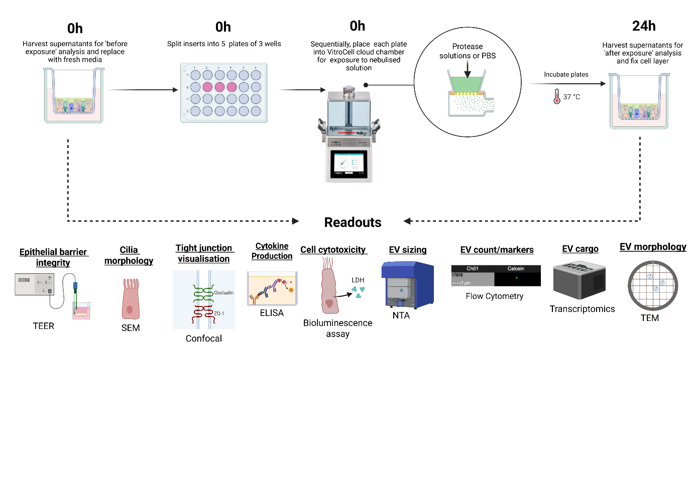
Figure 2. Epithelial cell exposure protocol

Bioinformatics analysis:
- You will be given access to the raw miRNA reads for EVs produced after exposure to each of the allergens.
- You can then perform quality control, read alignment, and transcript quantification, followed by differential expression analysis to identify miRNAs selectively enriched in EVs between conditions.
- Functional annotation and pathway enrichment analyses will be used to explore the biological relevance of EV RNA cargo, with particular focus on immune and inflammatory pathways relevant to airway biology.
Key questions:
- After protease, HDM, and dog allergen exposures to the epithelial cells, does the miRNA cargo of the EVs produced change in response?
- If so, what is the biological importance of the miRNAs that changed in expression? Are they involved in epithelial inflammation?
References:
https://isevjournals.onlinelibrary.wiley.com/doi/10.1002/jev2.12124
https://www.nature.com/articles/s42003-024-06197-3
https://onlinelibrary.wiley.com/doi/10.1111/all.14008

